# JavaScript for Front-End – Retake Exam Job Offers

You have been tasked to create a simple Front-End application, which looks like a **job offers platform**. You should create an interface that allows the user to **login, see notifications, create offers, archive offers** and **logout**.

## Task

The task is split into **2 sub-tasks**:

* A simple but fancy **web page design**.
* A simple but dynamic **web page functionality**.

The clients are understanding people, and they understand that you are quite novice as a developer, so they are willing to accept **ONLY** the **web page design** (without **functionality**) or **ONLY** the **web page functionality** (without **design**), if you are **unable** to **implement** one or the other.

## Overview

### Web Page Design

The web page should look like this **WITHOUT design**.

* When the user is **logged out**:

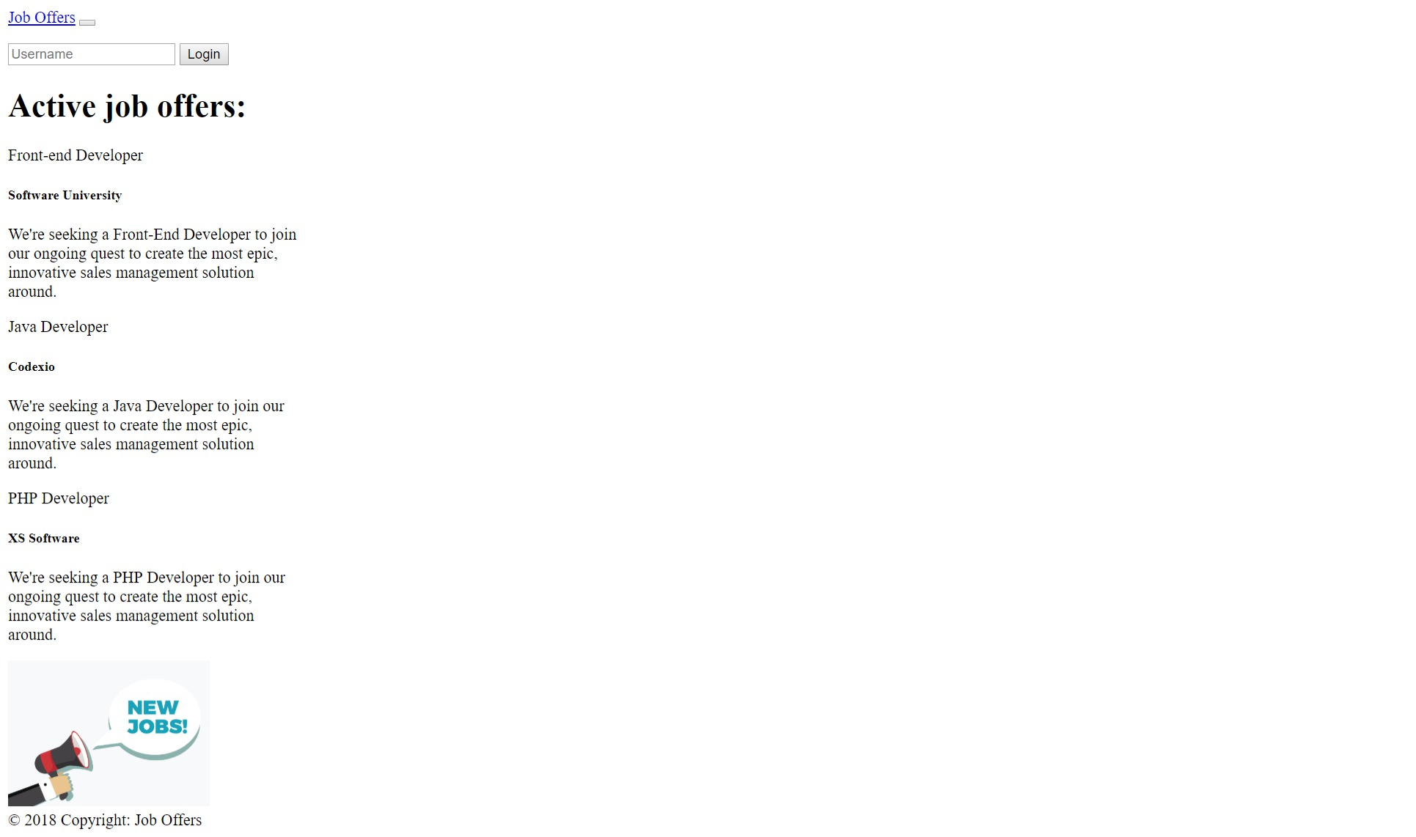

* When the user is **logged** **in**:

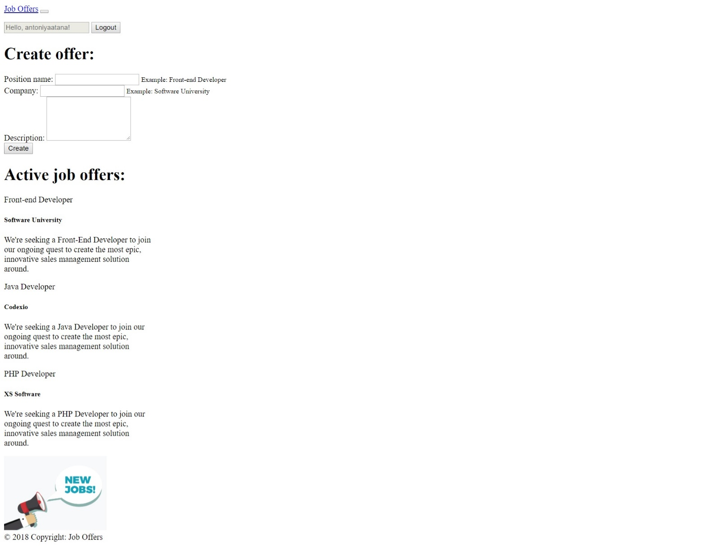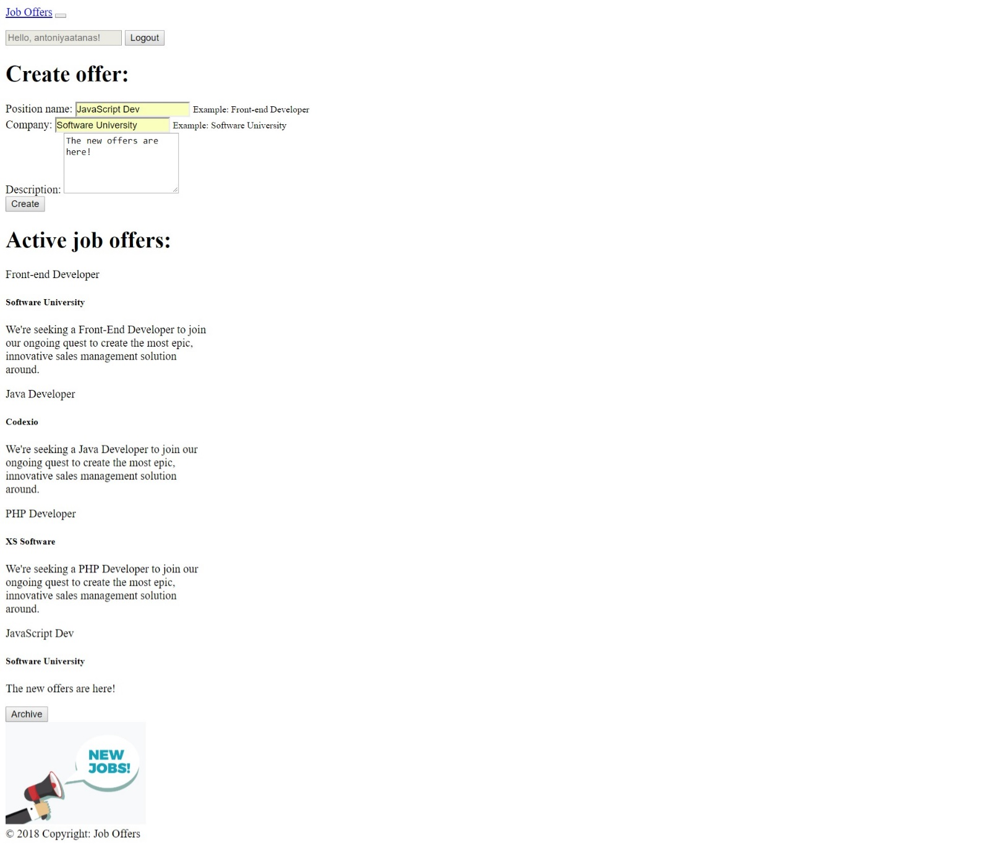

The web page should look like this **WITH design**:

* When the user is **logged out**:

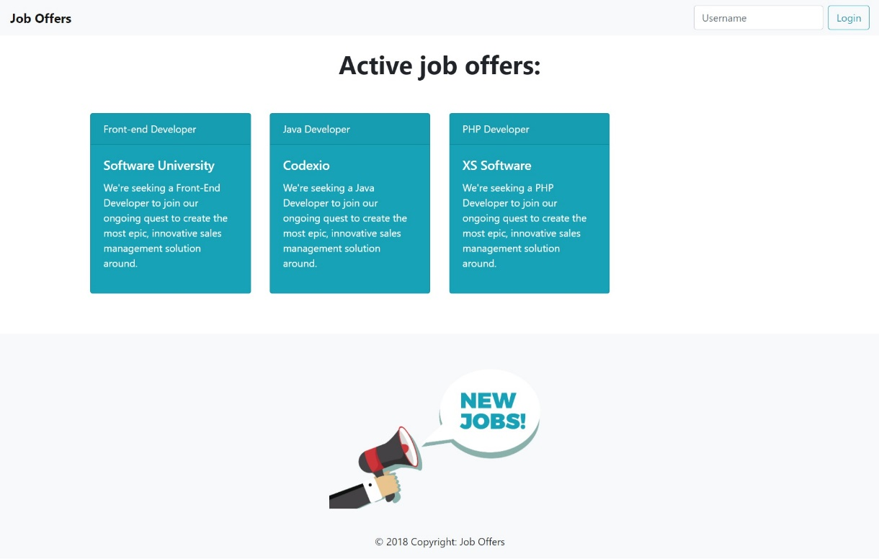

* When the user is **logged** **in**:

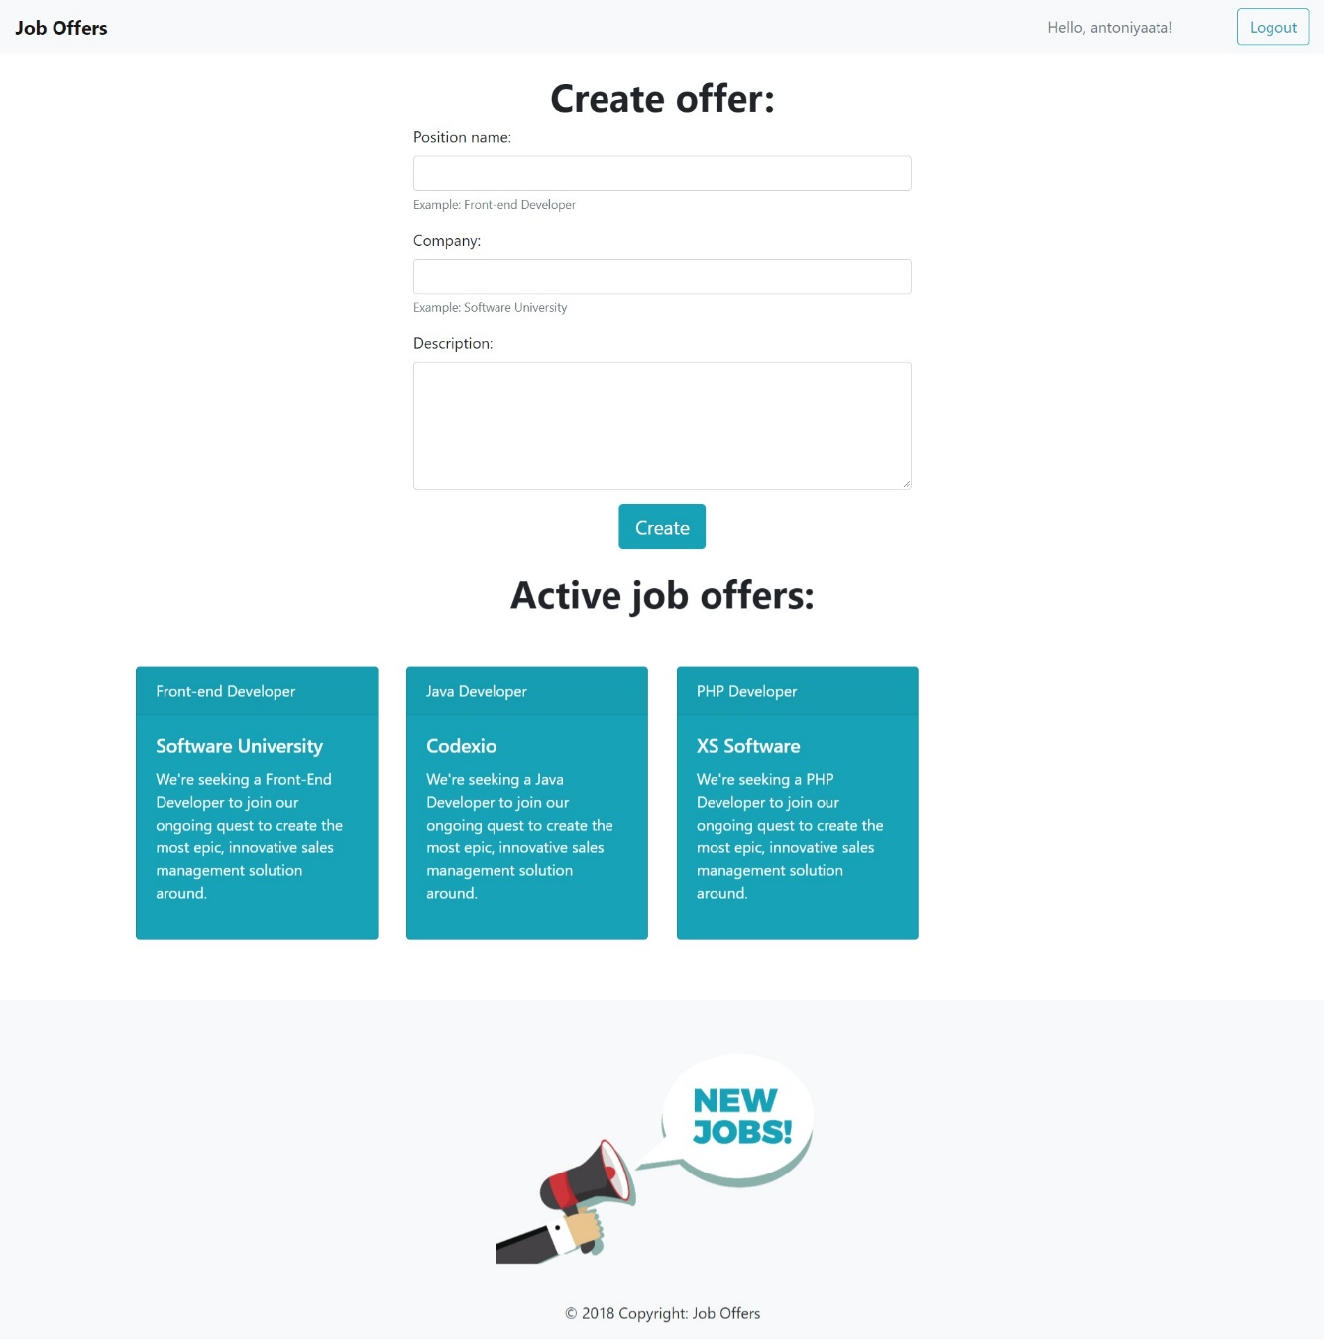

### Web Page Functionality

The application contains **5 main functionalities**:

* **Login**
* **Show notifications**
* **Create** offers
* **Archive** offers
* **Logout**

#### Login

The application should provide functionality to **login** with **username**. The username should have **validations.**

* The username should **NOT** be an empty space
* The username length should be **between 10 and 14** symbols

#### Show notifications

If the user don’t enter the data **correctly** you should show him the following **notifications**:

* **“The username should not be empty space!”**

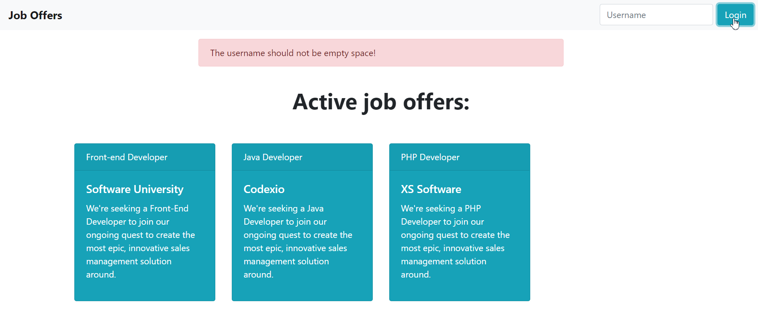

* **“The username should have length between 10 and 14 symbols!”**

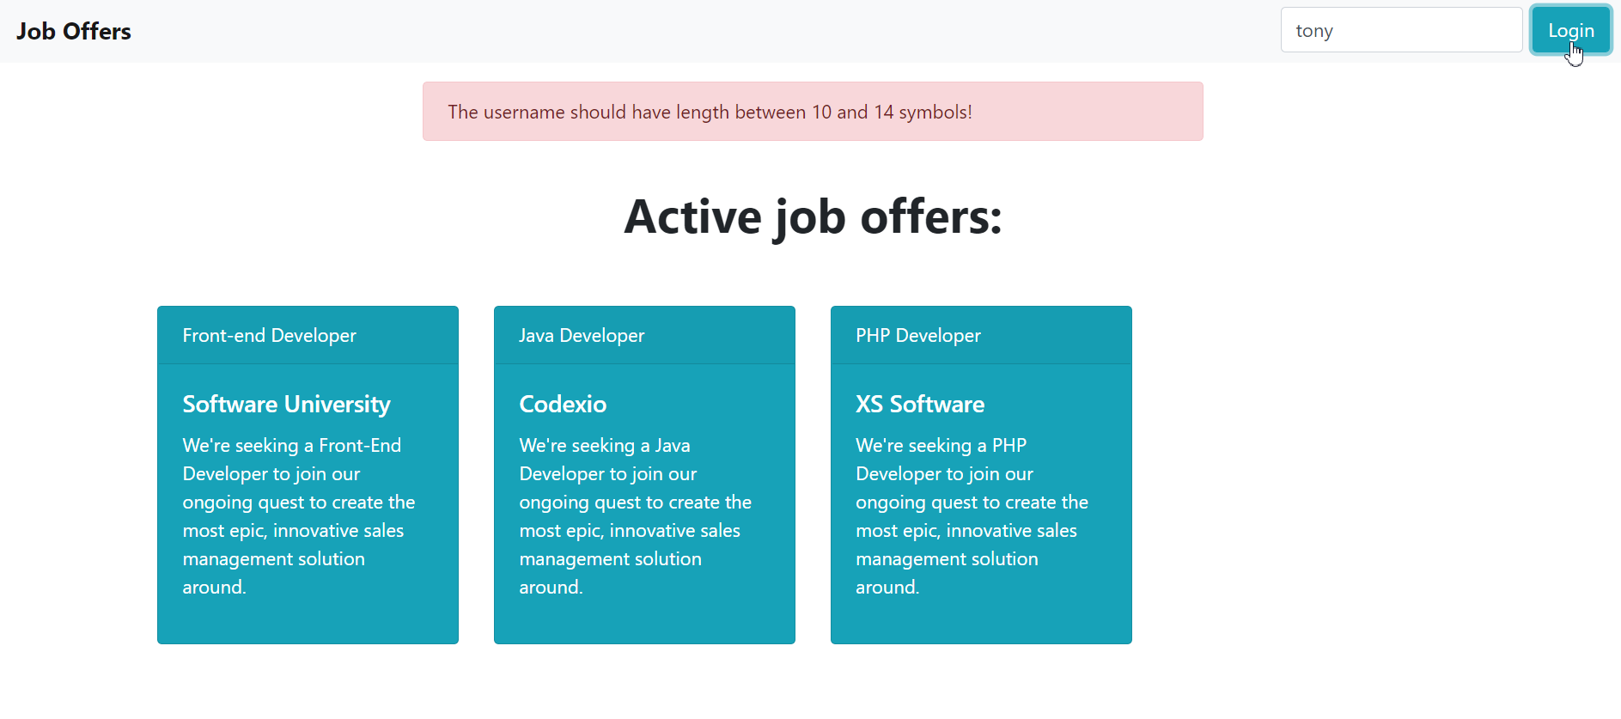

If he enter the data correctly he should see the **“Login successful!” notification**:

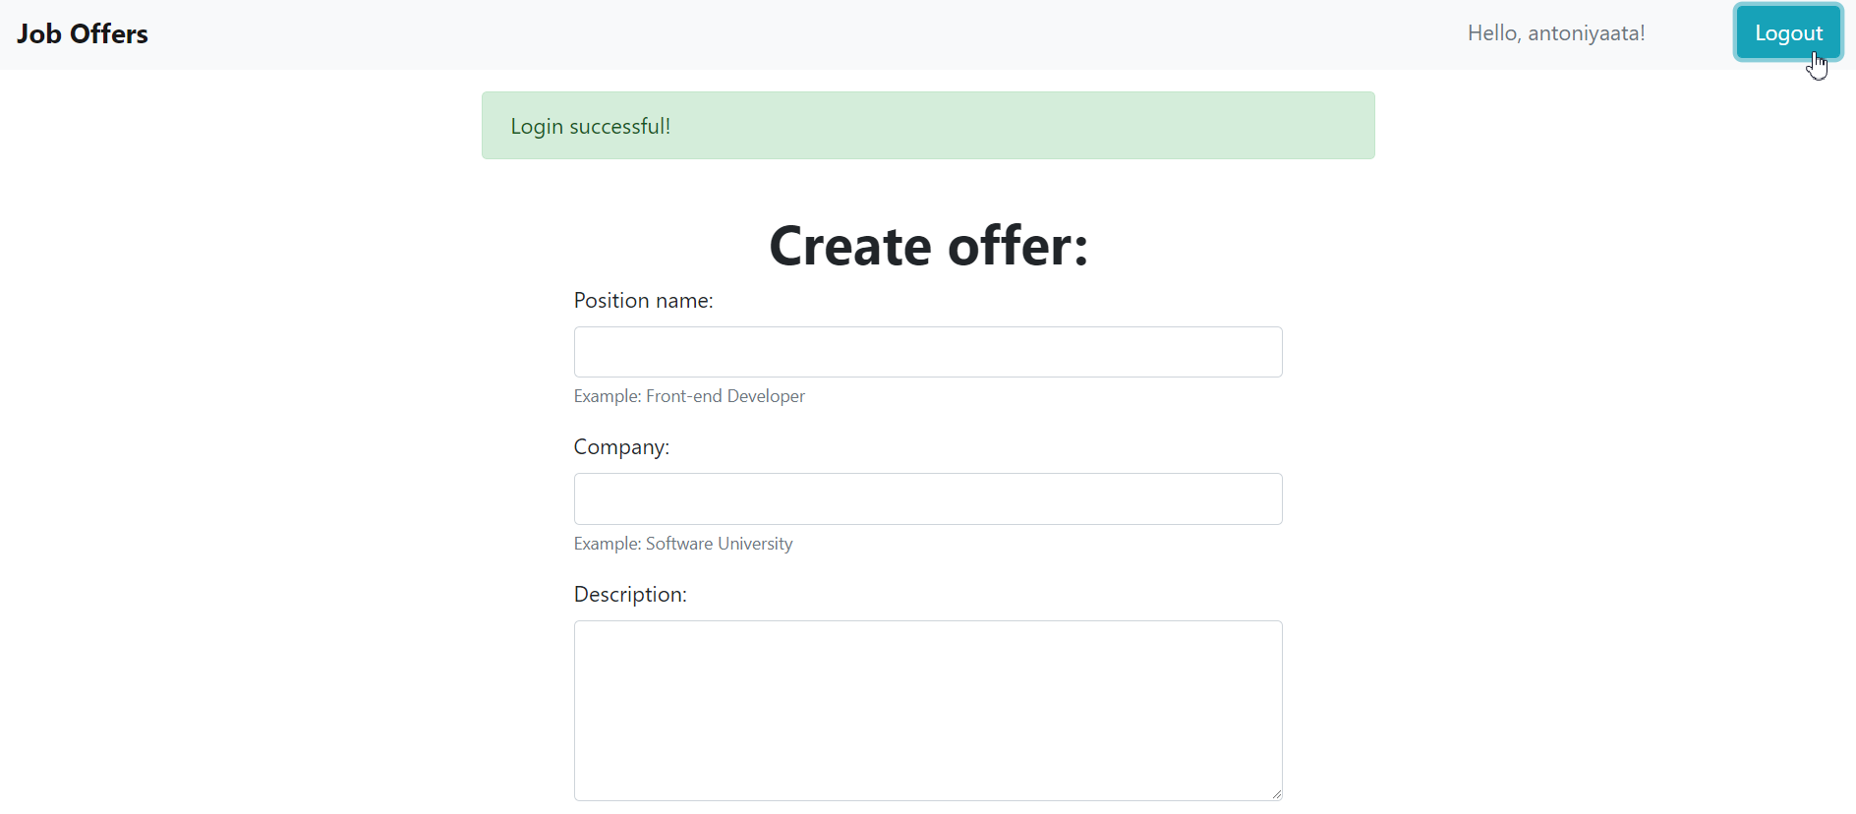

#### Create offers

The application should provide functionality to **create offers** for **logged users**. If the user is **logged in** he must be able to see the **form** for **creating** **offers**.

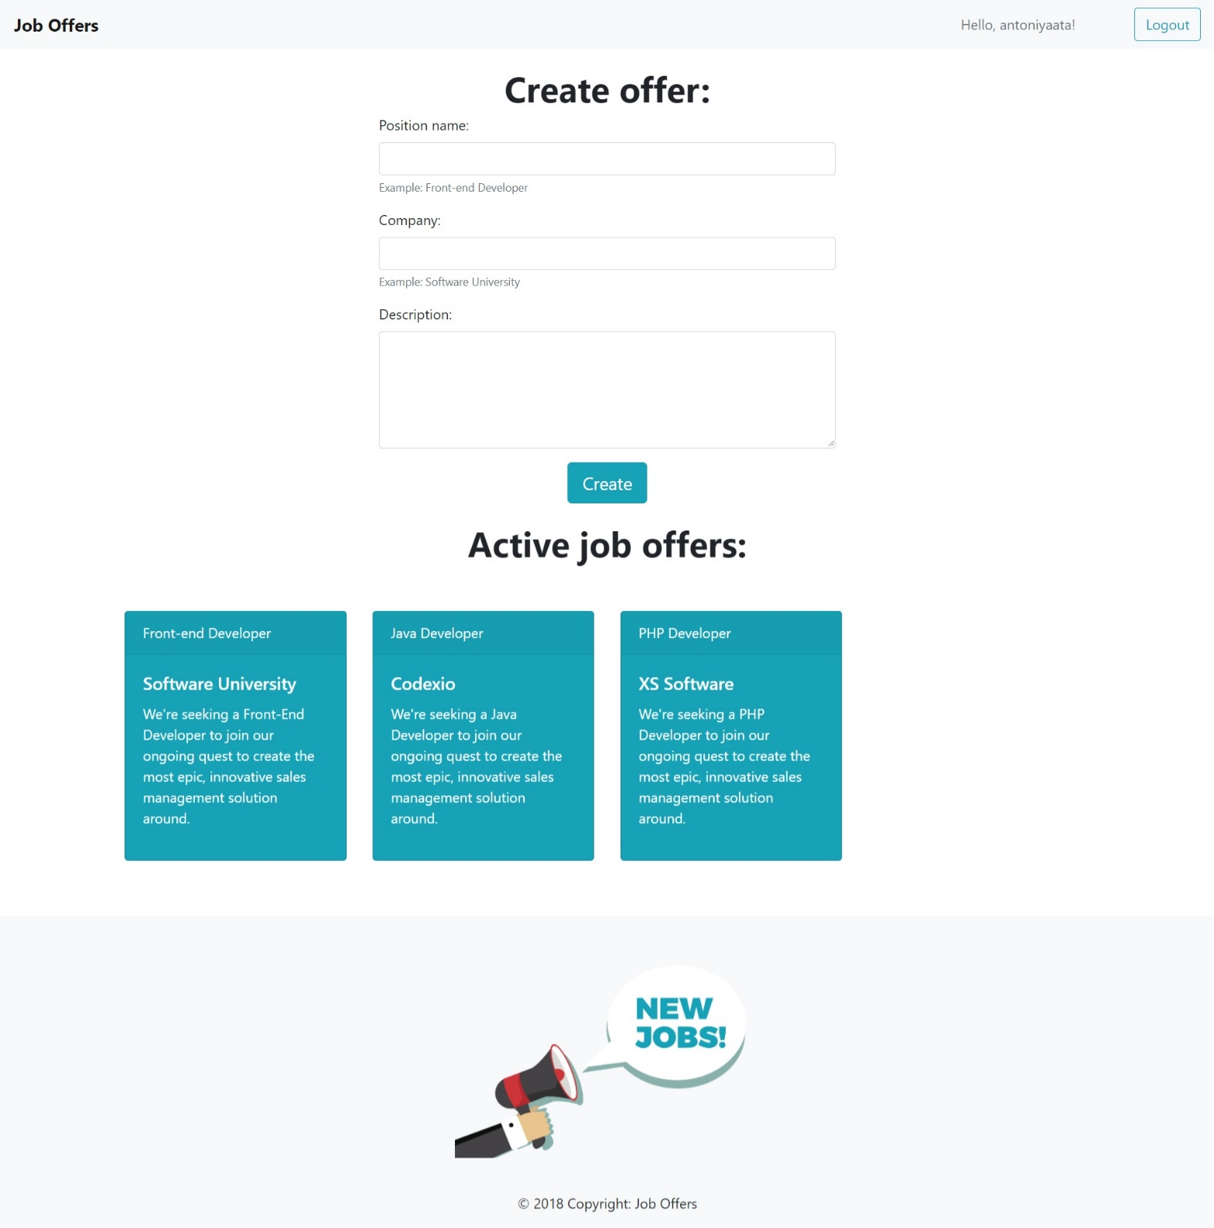

The form should have input fields for job **position**, the **company** that offers the job and job **description**. After creating the offer should be displayed in the **offers section** with **[Archive]** option.

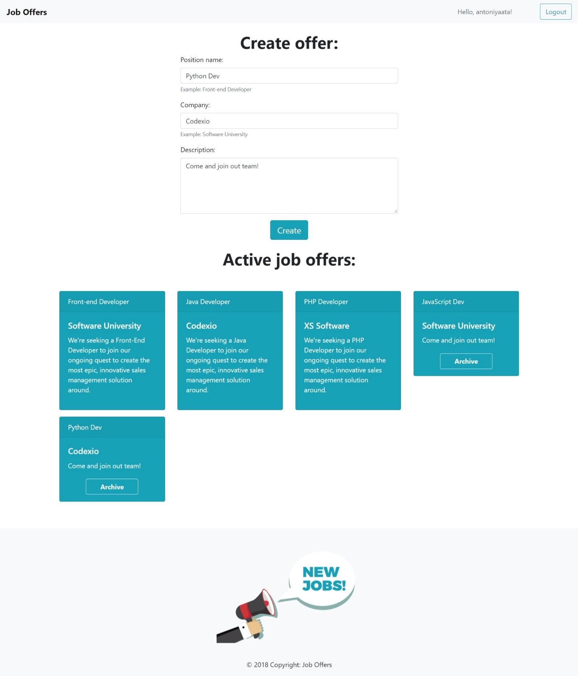

#### Archive offers

The application should provide functionality to **archive** the **created offers**.

All of the created offers should have **[Archive]** button. If user **click** the **[Archive]** button the offer should be **deleted** from the list.

#### Logout

The application should provide functionality to **logout**.

When user click the **[Logout]** button he should be able to see the **Login functionality** again.

## Constraints

The clients are not that much into Front-End technologies, however:

* They heard **Bootstrap** is a good web page styling framework, and they have requested that you **use it**.
* They heard JavaScript makes pages quite dynamic, and **jQuery** is a good library, so you must **use it**.

That being said, you have several constraints to follow, during the implementation of the web application:

* You must use **ONLY** **Bootstrap** for the **web page design**.
* You must use **ONLY** native **JavaScript** & **jQuery** for the **web page functionality**.

## Hints

You can check how to use **fadeTo and slideUp functions** inJavaScript to implement the notifications correctly.